**PUBLISH DATA TO THE IBM CLOUD**

|  |  |
| --- | --- |
| Team ID | PNT2022TMID08806 |
| Project Name | Hazardous Area Monitoring for Industrial Plant powered by IoT |

WOKWI Simulation using ESP32 and Ultrasonic Sensor:

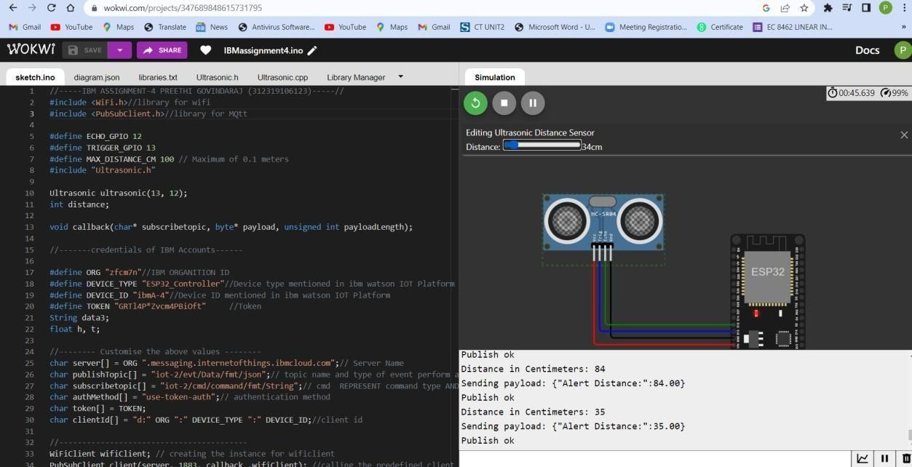

IBM WATSON PLATFORM DEVICE-EVENT LOG:

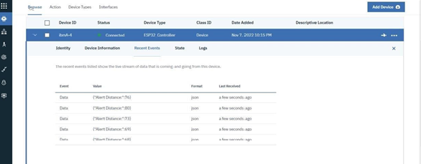

IBM WATSON PLATFORM DEVICE-EVENT PAYLOAD:

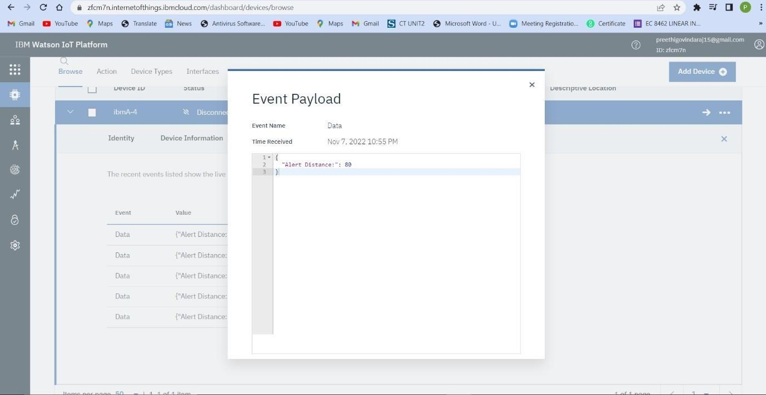

IBM WATSON PLATFORM DEVICE-BOARD AND GRAPHICAL REPRESENTATION OF DATA FROM WOKWI SIMULATION:

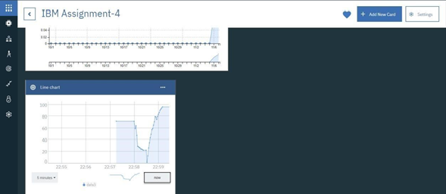

IBM CLOUDANT DB DATA LOG:

